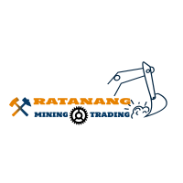 |  | LETTER OF INTEND
RE: LETTER OF INTEND tO SUPPLY TRUCKS |  | Date: 10/10/2019
RATANANG MINING &TRADING (PTY)LTd
REG:2016/287691/07
VAT:4470286941
Paye:7190805871
Coida :900113567
No:781
Enkeldoorn ave
Rose acres Estate
Montana Park
Pretoria

Tell:01224401126/0798986928
Fax:0865683245
Email:ratanangtrading86@gmail.com
Email:truckingloads@highveldmail.co.za

COMMODITY | LOADING POINT | OFF-LOADING POINT | RATE PER TON | KILOMETRES ROUND TRIP | Payment terms | Operating Hours
Chrome/NIckel | Columbus stainless steel | Middleburg ferro chrome | R115.000 per forth night | 12km round trip | Fortnightly | 7am-10pm
 |  | TOTAL EXCLUSIVE OF VAT
 |  | VAT 15%
 |  | TOTAL INCLUSIVE OF VAT

